**CDRL: A008 Scientific and Technical Reports**

Internal Testing and Evaluation/Interim Results

Contact No: N6600117C2001

Prepared by: Next Century Corporation

2701 Technology Drive Suite 100

Annapolis Junction, MD 20701

WARNING: This document contains technical data whose export is restricted by the Arms

Export Control Act (Title 22, U.S.C., sec. 2751, et seq.) or the Export Administration Act of

1979, as amended, Title 50, U.S.C., App. 2401 et seq. Violation of these export laws are

subject to severe criminal penalties. Disseminate in accordance with the provisions of DoD

Directive 5230.25.

SAVIOR User Information

Version 2, January 2019

# Using the SAVIOR Desktop

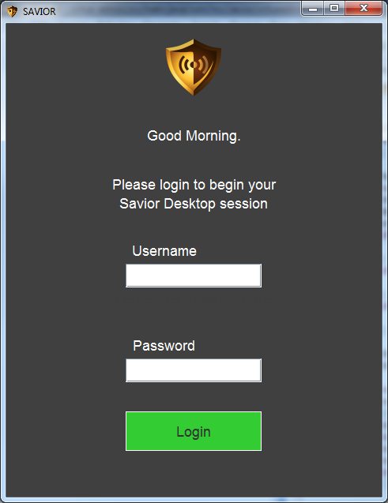

1) Upon starting the Savior Desktop application, users will either be prompted for User Name and Password or will automatically be logged on with their domain credentials depending on configuration. The User should enter the relevant information and select 'Login' if prompted.

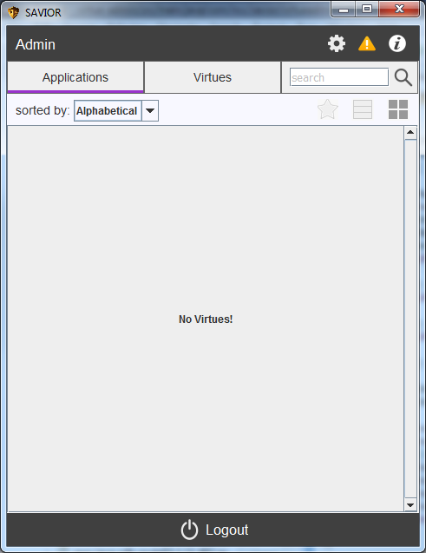

2) If the desktop shows an empty list, the user does not have any Virtues assigned to them. Consult the administrators guide to ensure how to assign Virtues to users.

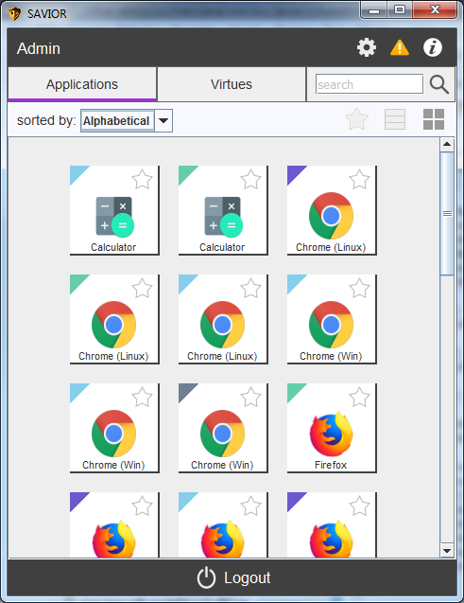

3) Once logged in, the user will be shown their user name along with a list of available Applications which are color coded to their respective virtues. Colors for virtues are set in the Admin Workbench by an administrator.

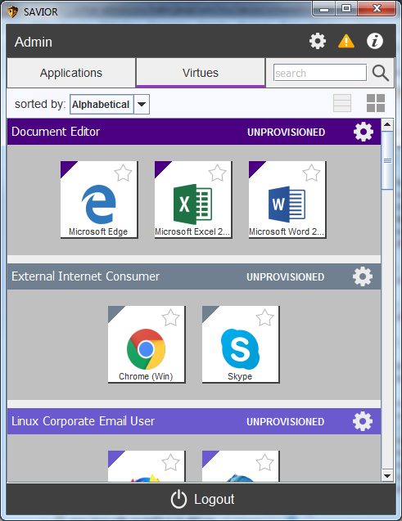

4) Users can also display applications by virtue by selecting the ‘virtues’ tab. This view will show the status of the view as well.

5) To start an application, click on the desired application. By default, a popup will display confirming you want to start that application. If the virtue is not already been provisioned, it will start going through the provisioning process and the application will be displayed soon after the virtue reaches the ‘running’ state.   
  
Note: From start to finish, provisioning can take about 5 minutes in the current iteration.

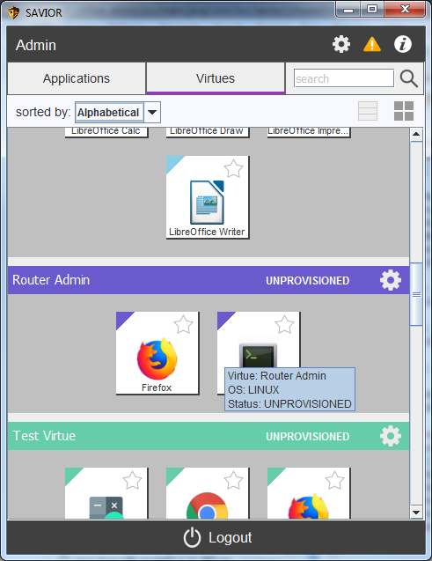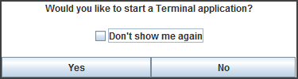

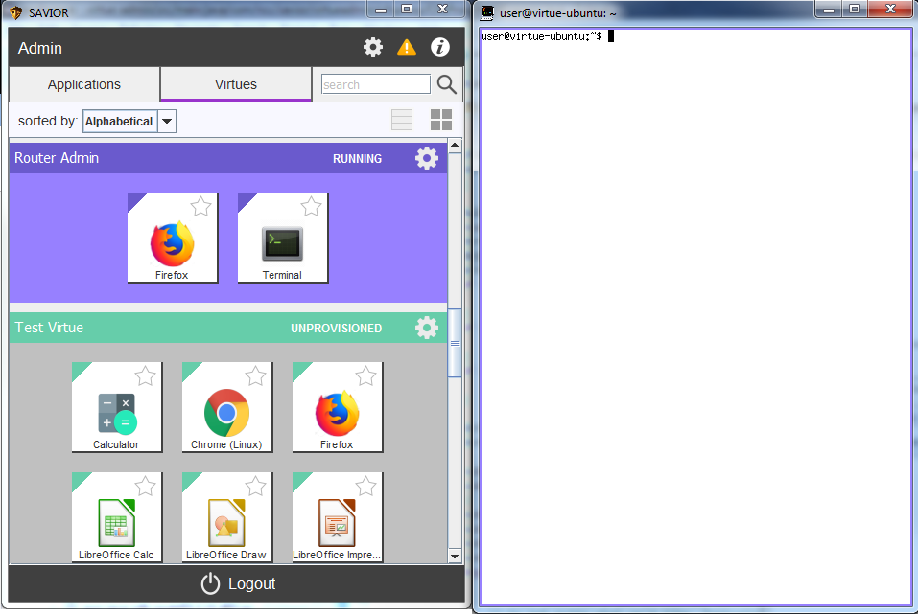

6) Once the Virtue is provisioned, the application selected will automatically start and be sent to the user's screen. The user can then use the application as is. The applications will also contain the color of the virtue.

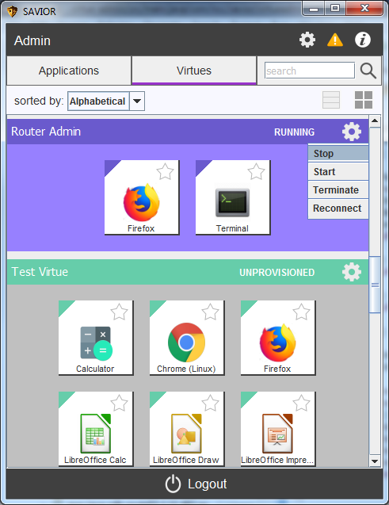7) To close an application, the user should select the "x" icon to close as normal for their local operating system (top-right corner for Windows). Some applications use their own decorations instead of the operating system decorations and those have their own method to close specific to the application. For example, Chrome uses its own decorations which are very similar to Windows, but not identical.

Other supported operations:

* Starting, stopping, and terminating virtues: To start, start or terminate a virtue, click on the gear icon on the far right of the virtue and select the appropriate option. Stopping and terminating will close the applications running on that virtue.

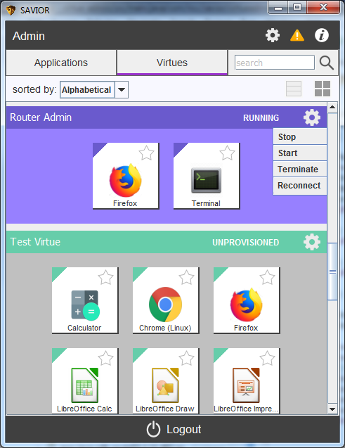

* Resuming old sessions after the desktop application has closed: If the desktop application is closed while applications are running, the user’s progress is not lost. Those applications should still be running on their respective VMs. To resume the applications, click on the gear icon on the far right of the virtue and select ‘reconnect’
* Alternative views: The desktop application also supports alternative views to fit the user’s preference.
  + Users can change how virtues/applications are sorted view the ‘sorted by:’ drop down menu.
  + Users can change the way applications are grouped view the ‘Applications’ and ‘Virtues’ tabs on the top.
  + Users can filter applications by typing into the search bar at the top
  + 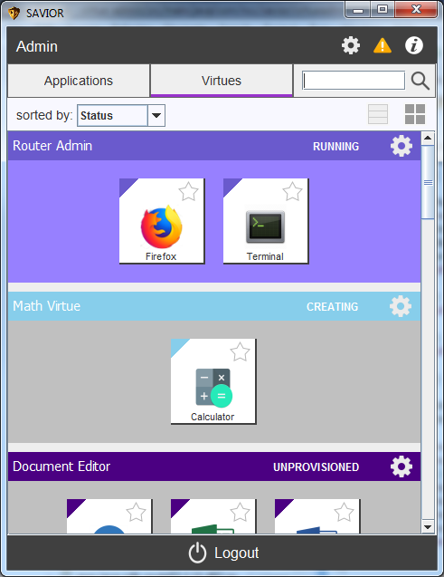Users can organize the virtues/applications differently via the icons to the right of the ‘sorted by:’ drop down.